Steps taken to get Django working in PyDev/ LiClipse

1. Set up virtual environment inside your workspace

python3 -m venv sampleapp

2. Navigate to new environment folder and activate the virtualenv

run the following commands in order:

cd sampleapp
source bin/activate
pip install --upgrade pip
pip install django~=1.11.0
django-admin startproject mysite .

3. Create a new python interpreter in PyDev pointing it the python installation you created in the virtual environment
Windows -> Preferences -> PyDev -> Python Interpreters -> New
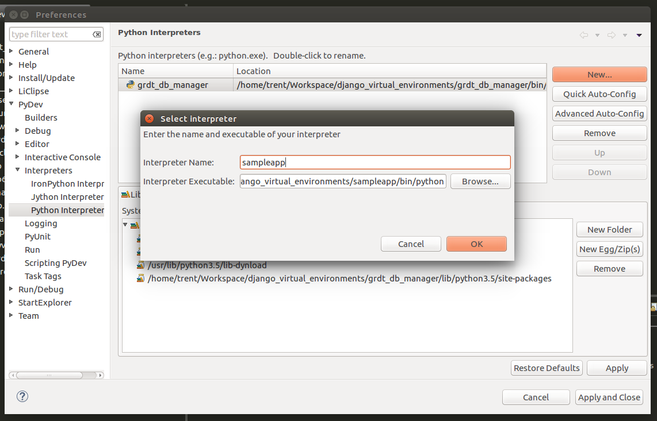
The “Interpreter Executable” points to the python installation in the project (the project should be located inside your workspace).

Click “OK” and select everything in the next screen (all unselected options) and then hit OK.
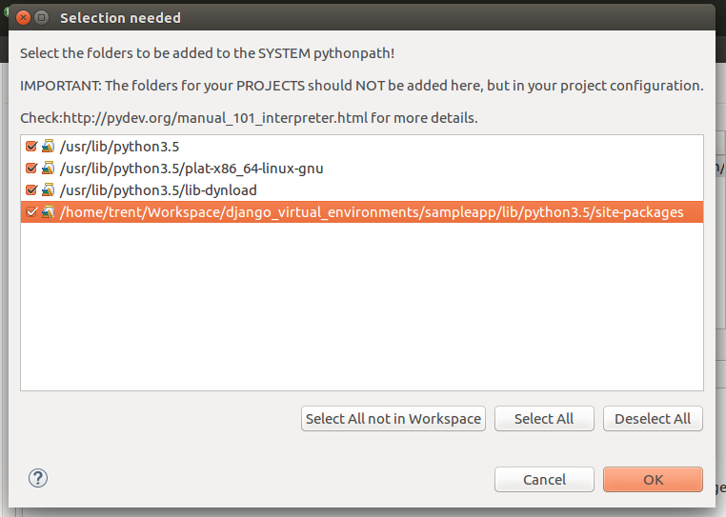
Now select “Apply and Close”.

4. Add a new django project in PyDev and choose the sampleapp folder you just created. Make sure to select the Python Interpreter created in step 3.

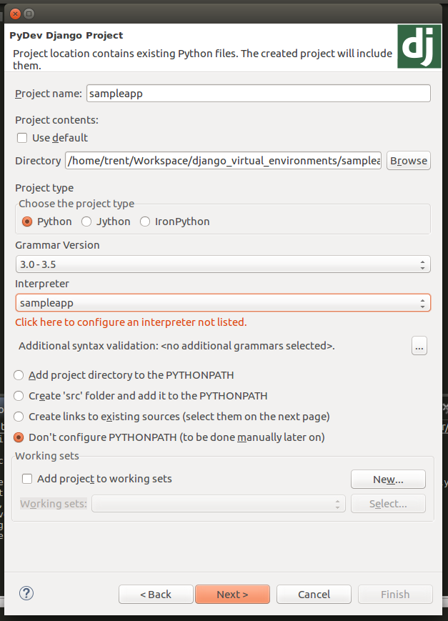
Click “Next” and fill in Database details as appropriate. Make sure to select the version of Django that you are using:

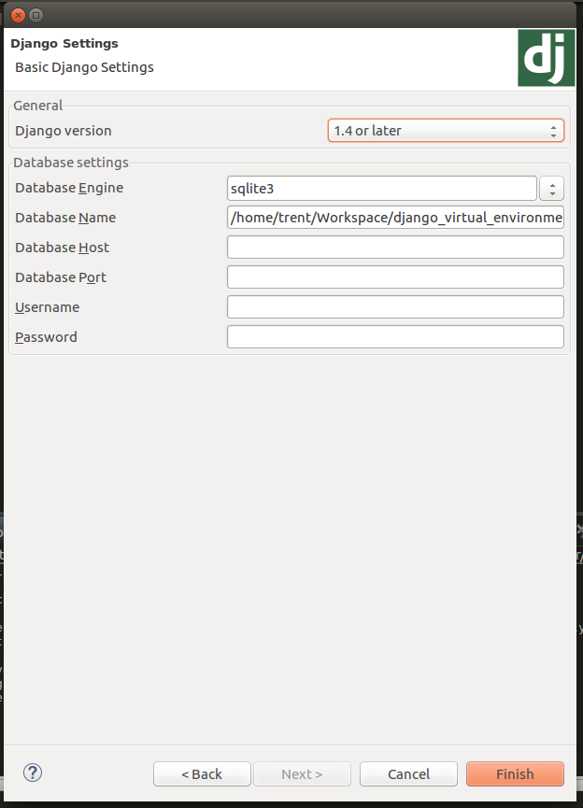
Click “Finish”.

5. Go to “Run Configurations” in PyDev to create the setup to start Django

Create a new run configuration under “PyDev Django” and fill out the form as below:

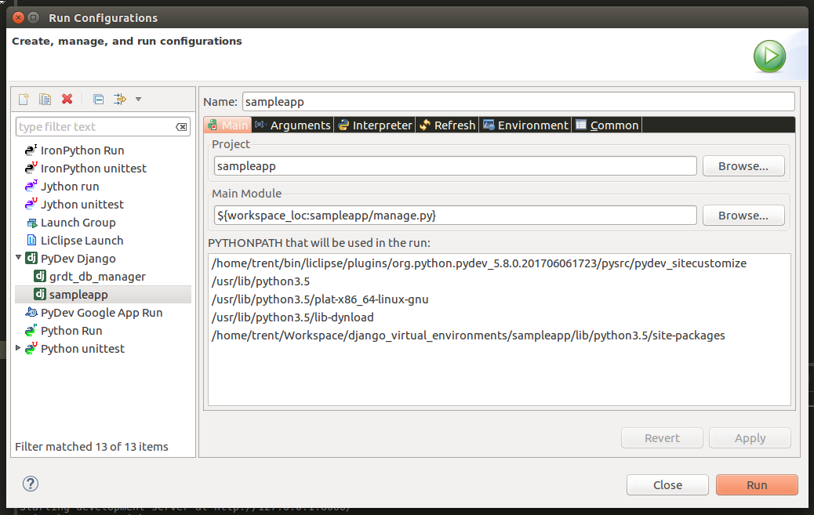
In the arguments tab add “runserver” as the argument that is passed to the project’s ‘manage.py’.

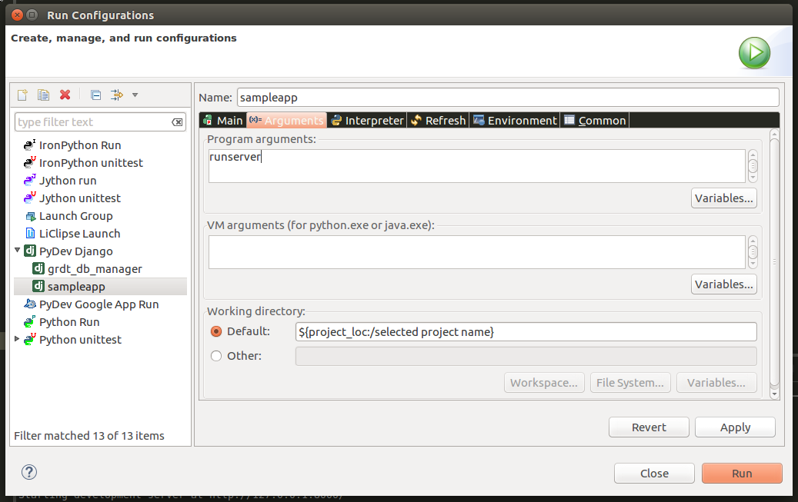

Hit “Apply” and then “Run”
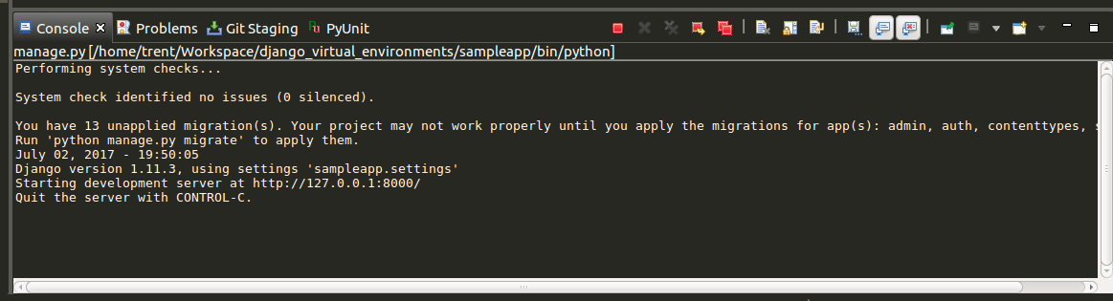
Navigate to the url ‘http://127.0.0.1:8000/’ which is displayed in PyDev’s console:

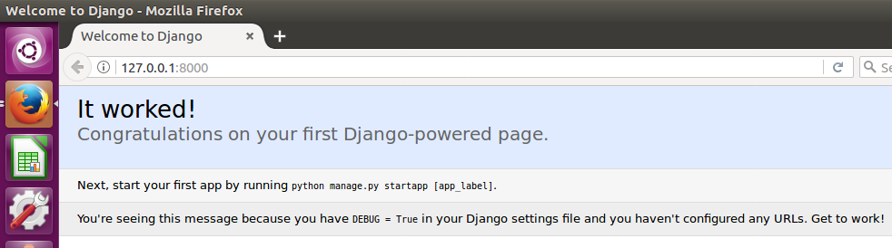

Congratulations, you are now able to start Django from PyDev!
Useful Information
https://tutorial.djangogirls.org/en/django_start_project/

manage.py is a script that helps with management of the site. With it we will be able (amongst other things) to start a web server on our computer without installing anything else.

The settings.py file contains the configuration of your website.

urls.py file contains a list of patterns used by urlresolver.

django-admin.py is a script that will create the directories and files for you. You should now have a directory structure which looks like this:

sampleapp
├───manage.py
└───mysite
settings.py
urls.py
wsgi.py
__init__.py

References

1. Django installation - https://tutorial.djangogirls.org/en/django_installation/

2. Debug Django in PyDev - http://arcoleo.org/dsawiki/Wiki.jsp?page=Debug%20Django%20in%20PyDev

